Cache:
Cache is a temporary storage location where frequently used data is stored so that it can be retrieved faster when needed again.
- Frequently used data is stored in cache memory.
- A temporary copy of data is saved for future use.
- It improves performance by reducing the time needed to access data.

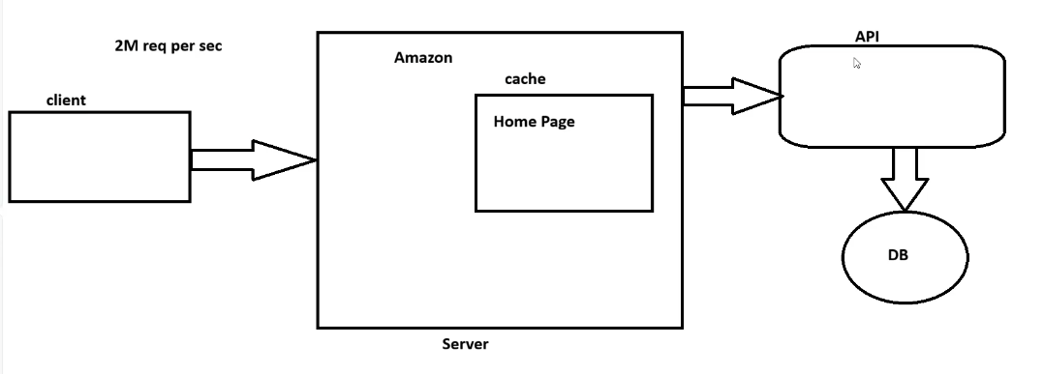
if a millions of people accessing amazon… the cache memory will store the home page to reduce the time of getting it from the database

Persist: Where do we want to store

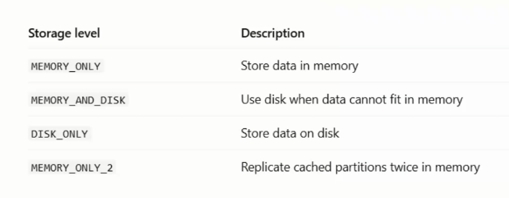
Unpersist: remove from the cache because data won’t be same at all time

